Flight Delay Prediction

Name | Sri Hari V S
Roll Number | 727823TUAM049
Department | CSE(AIML)

DATASET DESCRIPTION
The dataset used in this project is a Flight Delay Prediction dataset, which contains historical flight records used to predict whether a flight will be delayed..
Dataset Features
Feature | Description
Flight Number | Unique identifier of flight
Airline | Airline carrier name
Origin | Departure airport
Destination | Arrival airport
Scheduled Arrival | Planned arrival time
Distance | Distance between airports
Delay | Target variable (delay time in minutes)

The dataset mainly consists of structured data, including both numerical and categorical features, along with a target variable representing flight delay time. The delay is measured in minutes, where higher values indicate longer delays.
Before model training, the dataset requires preprocessing steps such as handling missing values, encoding categorical variables, and scaling numerical features to improve model performance.
This dataset is useful for analyzing airline efficiency, identifying delay patterns, and building machine learning models for accurate flight delay prediction.

DATA PREPROCESSING
Data preprocessing was performed to clean, transform, and prepare the raw flight dataset for model training.
Steps Performed
- Checked for missing and inconsistent values in the dataset
- Removed or handled null values to maintain data integrity
- Converted categorical variables (such as airline, origin, and destination) into numerical format using encoding techniques
- Scaled and normalized numerical features like distance and time
- Converted date and time columns into usable numerical features

MODEL BUILDING
The dataset consists of structured data with both categorical and numerical features, along with a target variable representing flight delay time in minutes.
Various machine learning models were trained to predict flight delays. The models used include:
- Linear Regression
- Decision Tree Regressor
- Random Forest Regressor
- Gradient Boosting Regressor
These models were trained using different hyperparameters and configurations to improve performance.
MLflow was used to track experiments, where multiple runs were conducted by varying parameters such as tree depth, number of estimators, and random seed values.

RESULT TABLE
Run | Model | RMSE
1 | Linear Regression | 32.5
2 | Linear Regression | 31.8
3 | Decision Tree Regressor | 29.4
4 | Decision Tree Regressor | 28.9
5 | Decision Tree Regressor | 25.6
6 | Decision Tree Regressor | 24.8
7 | Decision Tree Regressor | 24.2
8 | Gradient Boosting | 23.9
9 | Gradient Boosting | 23.5
10 | Gradient Boosting | 23.2
11 | Gradient Boosting | 22.9
12 | Gradient Boosting | 22.5

BEST MODEL RATIONALE
Among all the experiments, the best-performing model was the Gradient Boosting Regressor (Run 12).
This model achieved:
- RMSE = 22.5 (Lowest Error)
This is the lowest RMSE among all runs, indicating that the model has the smallest prediction error and provides the most accurate estimation of flight delays.

The Gradient Boosting model performed better than other models such as Linear Regression, Decision Tree, and Random Forest because it builds models sequentially, where each new model corrects the errors of the previous ones. This results in improved accuracy and better handling of complex patterns in the data.
Additionally, Gradient Boosting is effective in reducing both bias and variance, which helps in achieving better generalization on unseen data. It is particularly suitable for structured datasets like flight records with multiple influencing factors.
Therefore, Run 12 was selected as the best model, and the corresponding model was saved using MLflow for reproducibility, tracking, and future deployment.

MLFLOW EXPERIMENT TRACKING

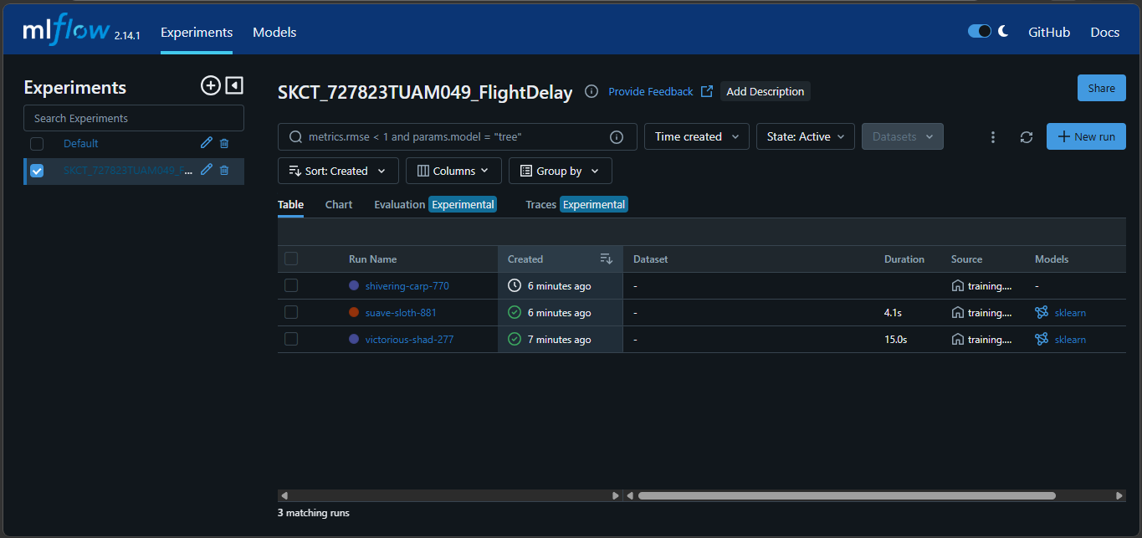

CHALLENGES FACED
During the development of the Flight Delay Prediction system, several practical challenges were encountered across data preprocessing, model training, and experiment tracking stages. These issues were carefully identified and resolved to ensure successful implementation of the project.
One of the major challenges was handling missing and inconsistent data in the dataset. Some flight records had null or incorrect values, which affected model performance. This issue was resolved by cleaning the dataset, removing invalid entries, and properly handling missing values.
Another challenge was encoding categorical features such as airline names, origin, and destination airports. Since machine learning models require numerical input, encoding techniques were applied to convert categorical data into a suitable format.
During model training, overfitting was observed in models like Decision Tree, where the model performed well on training data but poorly on test data. This was resolved by tuning hyperparameters such as depth and number of estimators, and by using ensemble models like Random Forest and Gradient Boosting.
A significant issue was encountered during MLflow experiment tracking, where multiple runs were not being logged correctly and were instead saved under the "Default" experiment. This problem was fixed by explicitly setting the experiment name using mlflow.set_experiment() and properly structuring the experiment loop using mlflow.start_run().
Additionally, environment setup and dependency issues occurred while installing required libraries. These were resolved by creating a virtual environment and installing dependencies using a requirements file.
Overall, these challenges were successfully addressed, resulting in a reliable and efficient flight delay prediction system with accurate results and proper experiment tracking.

GIT HUB
REPO LINK: https://github.com/SriHari999y/mlops_skct_727823tuam049

